FLOOD PREDICTION USING AI MODEL

A PROJECT REPORT

Submitted by
KASAVARAJU SAI HIMAJA 211418104113
T KUMUDBEN JOSHI 211418104296
THIRIVEEDHI VENKATA LAKSHMI DHARANI 211418104293

in partial fulfillment for the award of the degree of
BACHELOR OF ENGINEERING

in

COMPUTER SCIENCE AND ENGINEERING

PANIMALAR ENGINEERING COLLEGE
(An Autonomous Institution, Affiliated to Anna University, Chennai)

MAY 2022

PANIMALAR ENGINEERING COLLEGE

(An Autonomous Institution, Affiliated to Anna University, Chennai)

BONAFIDE CERTIFICATE

Certified that this project report “FLOOD PREDICTION USING AI MODEL” is the bonafide work of “T.KUMUDBEN JOSHI (211418104296),
THIRIVEEDHI VENKATA LAKSHMI DHARANI(211418104293),
K.SAI HIMAJA(211418104113) ” who carried out the project work under my supervision.

SIGNATURE SIGNATURE

Dr.S.MURUGAVALLI,M.E.,Ph.D., Mrs.M.S.VINMATHI,M.E(Ph.D)
HEAD OF THE DEPARTMENT SUPERVISOR PROFESSOR
DEPARTMENT OF CSE, DEPARTMENT OF CSE,
PANIMALAR ENGINEERING COLLEGE, PANIMALAR ENGINEERING COLLEGE,
NASARATHPETTAI, NASARATHPETTAI,
POONAMALLEE, POONAMALLEE,
CHENNAI-600 123. CHENNAI-600 123.
Certified that the above mentioned students were examined in End Semester project viva-voice held on _________________________.

INTERNAL EXAMINER EXTERNAL EXAMINER

DECLARATION BY THE STUDENT

We Thiriveedhi Venkata Lakshmi Dharani (211418104293),T.Kumudben Joshi (211418104296),K.Sai Himaja (211418104296) hereby declare that this project report titled “ FLOOD PREDICTION USING AI MODEL” , under the guidance of Mrs.M.S.VINMATHI M.E.(Ph.D). is the orginial work done by us and we have not plagiarized or submitted to any other degree in any university by us.

K sai himaja

T kumudben joshi

Thiriveedhi venkata Lakshmi dharani

ACKNOWLEDGEMENT

We would like to express our deep gratitude to our respected Secretary and Correspondent Dr.P.CHINNADURAI, M.A., Ph.D. for his kind words and enthusiastic motivation, which inspired us a lot in completing this project.

We express our sincere thanks to our Directors Tmt.C.VIJAYARAJESWARI, Dr.C.SAKTHI KUMAR,M.E.,Ph.D and Dr.SARANYASREE SAKTHI KUMAR B.E.,M.B.A.,Ph.D., for providing us with the necessary facilities to undertake this project.

We also express our gratitude to our Principal Dr.K.Mani, M.E., Ph.D. who facilitated us in completing the project.

We thank the Head of the CSE Department, Dr. S.MURUGAVALLI , M.E.,Ph.D., for the support extended throughout the project.

We would like to thank my Project Guide Mrs.M.S.VINMATHI, M.E.(Ph.D) and all the faculty members of the Department of CSE for their advice and encouragement for the successful completion of the project.

KASAVARJU SAI HIMAJA
T KUMUDBEN JOSHI
THIRIVEEDHI VENKATA LAKSHMI DHARANI
ABSTRACT

Floods are among the most destructive natural disasters, which are highly complex to model. The research on the advancement of ﬂood prediction models contributed to risk reduction, policy suggestion, minimization of the loss of human life, and reduction the property damage associated with ﬂoods. To mimic the complex mathematical expressions of physical processes of ﬂoods, during the past two decades, neural network methods contributed highly in the advancement of prediction systems providing better performance and cost-effective solutions. The analysis of dataset by Multi-Layer Perceptron Classifier (MLP) to capture several information’s like, variable identification, missing value treatments, data validation and data cleaning/preparing will be done on the entire given dataset. The performance of the algorithms will be shown in the form of graph and to understand it in better way confusion matrix graphs will be represented.

v
TABLE OF CONTENTS

CHAPTER NO. TITLE PAGE NO.
ABSTRACT v
LIST OF FIGURES viii
LIST OF TABLES ix
LIST OF ABBREVIATIONS x
1. INTRODUCTION 1-3
1.1 Problem Definition 2
1.2 Project Goals 3
2. LITERATURE SURVEY 4-12
3. SYSTEM ANALYSIS 13-20
3.1 Existing System 14

3.2 Proposed System 15

3.3 Feasibility Study 17
3.4 System Study 18
3.5 Hardware Environment 19
3.6 Software Environment 20
4. SYSTEM DESIGN 21-29
4.1. ER Diagram 22
4.2 Data Flow Diagram 23

4.3 UML Diagrams 24-28

4.4 Work Flow Diagram 29

5. SYSTEM ARCHITECTURE 30-46
5.1 Module Design Specification 32
5.2 Algorithms 46
6. SYSTEM IMPLEMENTATION 47-65
6.1 Module-1 Coding 48
6.2 Module-2 Coding 50
6.3 Module-3 Coding 53

6.4 Module-4 Coding 57

6.5 Module-5 Coding 61

6.6 Module-6 Coding 65

7. PERFORMANCE ANALYSIS 66-70
7.1 Accuracy & Comparison of results 67
7.2 Results Of Confussion Matrices 70

8. CONCLUSION 71-73
8.1 Conclusion 72
8.2 Future Enhancements 73
APPENDICES
A.1 Sample Screens 76

REFERENCES 77

LIST OF FIGURES

SL.NO TITLE PAGE.NO
01 Er – Diagram 21
02 Data Flow Diagram 22
03 Use Case Diagram 23
04 Class Diagram 24
05 Sequence Diagram 25
06 Collaboration Diagram 26
07 Activity Diagram 27
08 Work Flow Diagram 28
09 System Architecture 30
10 Module-1 Diagram 34
11 Module-2 Diagram 36
12 Module-3 Diagram 41
13 Accuracy Results Of Algorithm-1 43
14 Accuracy Results Of Algorithm-2 44
15 Accuracy Results Of Algorithm-3 46
16 Accuracy Results Of Algorithm-4 47
17 User Interface 82
18 Entering Rainfall Range 83
19 Predicted Output 83

viii
LIST OF TABLES

S.NO. TITLE PAGE.NO

7.1 Accuracy result 79

ix

LIST OF ABBREVATIONS

S. NO. ABBREVATION EXPANSION

1 ML Machine Learning
2 CS Computational Stylometry
3 CNN Convolutional Neural Network
4 LSTM Long Short-Term Neural Network
5 GCN Graph Convolutional Network
6 SIF Smooth Inverse Frequency
7 NLP Natural Language Processing
8 SVM Support Vector Machine
9 IT Information Technology
10 RAM Random Access Memory
11 GB Giga Byte
12 GHz GigaHertz
13 SGD Stochastic Gradient Descent
14 ANN Artificial neural network
15 MLP Multilayer perceptron
16 FFNN Feedforward neural network
17 BPNN Back propagation neural network

x

CHAPTER 1

1.INTRODUCTION

1.1Problem Definition
- Floods may only last few hours and can cause considerable damage and a possible threat to life. Flood prediction requires quantitative knowledge about infiltration and runoff dynamics, which is generally gained at the local scale. When scaling up local measurements to the catchment scale, account needs to be taken off the catchment’s organization (connectivity and patchiness).
- For this purpose, developed a new method to map soil vulnerability to floods based on two steps: (1) identification of the flow processes at the plot scale, and (2) up-scaling this knowledge to the catchment scale. Excess surface runoff was scaled up by means of terrain analysis using digital elevation models (TauDEMs) calibrated with in situ sprinkling experiments of three rainfall-simulation intensities carried out on 57 plots under grassland and forest that dominate in the investigated area.
. The marked differences in textural and structural porosities between forest and
grassland plots appear to control runoff processes.
. On the one hand, forest soil has a higher storage capacity than grassland soil,
probably caused by a high unsaturated hydraulic conductivity and root water
uptake, and resulting in lower surface runoff.

1.2 Project Goals

Exploration data analysis of variable identification
- Loading the given dataset
- Import required libraries packages
- Analyze the general properties
- Find duplicate and missing values
- Checking unique and count values

Uni-variate data analysis
- Rename, add data and drop the data
- To specify data type

Exploration data analysis of bi-variate and multi-variate
- Plot diagram of pairplot, heatmap, bar chart and Histogram

Method of Outlier detection with feature engineering
- Pre-processing the given dataset
- Splitting the test and training dataset
- Comparing the Decision tree and Logistic regression model and random forest etc.

Comparing algorithm to predict the result
- Based on the best accuracy

CHAPTER 2

2.LITERATURE SURVEY

1.Title: A Hybrid Machine Learning Approach for Classifying Aerial Images of
Flood-Hit Areas
Author: Akshya .J, P.L.K.Priyadarsini
Year: 2019
The classification is done on an image dataset which consists of two subgroups one is aerial images with flood-affected areas and other is aerial images without any flooded affected areas. The downloaded dataset is randomly partitioned then the classification of image is done.This classification involves hybridization of SVM classifier along with k-means clustering. The SVM classifier is used to train various categories of the dataset. Comparative studies show that SVM classifier is one of the preferable classifiers among all the others that are widely used in much remote sensing application and provides a much better accuracy when compared to other algorithms like decision trees. It was then used for solving multi-class classification problems. It builds a hyper plane that separates both the categories and is used for categorizing new images. Classifier is evaluated based on various parameters; some of them being accuracy, prediction speed and training time. The confusion matrix is built to represent the performance of the classifier. This matrix represents the number of correctly and incorrectly classified examples from the dataset. The performance of this methodology is evaluated. It is capable of classifying the flooded areas with good accuracy. This model classified 90% of flooded images correctly. A comparison is done with the accuracy of the model by training it with different environments and the results had been plotted. Kernel functions are also changed for the SVM classifier to plot the difference in the prediction and training time.

2.Title: Smart flood disaster prediction system using IOT & Neural Networks
Author: Swapnil Bande, Virendra V. Shete
Year: 2017
The integrated approach combines the scalability of IOT and reliability of artificial neural networks to handle data provided by a sensor network and by effective communication between these two components, an early prediction of flood is done. It had been proved that LevenbergMarquardt training algorithm with NARX network gives better results and provides real time flood prediction with step-ahead alert. The prediction chart indicates that the event of flood is predicted one time-step ahead and warns the communities at risk using Thing Tweet in simple to understand language with the use of Internet. Thus by harnessing latest technological disruptions such as IOT and machine learning, big data, predictive analytics along with social media and mobility allows effective emergency & disaster management for smart nations. The main aim of this system is to monitor humidity, temperature, pressure, rainfall, river water level and to find their temporal correlative information for flood prediction analysis The IOT approach is deployed for data collection from the sensors and communication over Wi-Fi and an ANN approach is used for analysis of data in flood prediction.

3.Title: Flood Prediction Using Multi-Layer Artificial Neural Network in Monitoring System with Rain Gauge, Water Level, Soil Moisture Sensors
Author: Febus Reidj G. Cruz, Matthew G. Binag, Marlou Ryan G, Francis
Aldrine.A
Year: 2018
This study was about to implement a real-time monitoring system capable of measuring parameters such as rainfall intensity, soil moisture, water level and rate of increase in water level. The different sensor was integrated into a system, wherein the data was logged and stored. A prediction model based on multi-layered artificial neural network was developed and was tested using an actual setup. This study validated the response of the multi-layered network model. The flood prediction model had a small deviation with reference to the actual water level, with RMSD of 2.2648.In the Philippines that was a major issue as it leads to damage of properties, damage to infrastructures or even loss of lives. Current systems adhere to solve issues to prevent devastating disasters caused by floods.Multi layered artificial neural network with the aid of MATLAB was used in the development of the prediction model. In the training, test, validation and overall dataset, the network showed a very good goodness-of-fit specifically 0.99889 for the training dataset, 0.99362 for the test data set, 0.99764 for the validation dataset and 0.99795 considering all the data in the dataset. The network was then programmed and integrated in the system in the actual setup. The model is validated by running trials with certain inputs and predicted flood level as the output and is compared to the actual flood level after a certain period of time. The flood prediction system showed an RMSD value of 2.2648 which signifies a small overall difference between the predicted flood level and actual flood level across the whole dataset tested in the actual setup.

4.Title: Floods Prediction Using Radial Basis Function (RBF) Based on Internet of Things (IoT)
Author: Ni Komang Ega Kartika, Muhammad Ary Murti, Casi Setianingsih
Year: 2019
Artificial Neural Networks had been trained on the data that are in the form of water level data and rainfall data which is used to predict the water level and daily rainfall for the next month. The parameters used to get the smallest error rate in the prediction process of water level and rainfall with the best radial basis function neural network is to use 700 times iterations and use the learning rate that equal to 0.00007.Here the flood was predicted using Radial Basis Function. The data was received from Citarum River Hall. The result from Radial Basis Function Neural Network is sent to an android application that displays the opportunity of flooding. Using epoch as much as 700 giving error value of TMA equal to 0.027 and error value of CH equal to 0.002, a learning rate of 0.00007 giving error value of TMA equal to 0.286 and error value CH equal to 0.002, and a hidden neuron of 2 giving error value of TMA equal to 0.6483 and error value of CH equal to 15.999 can be used to predict the flooding.
5.Title: An Efficient Automated Hybrid Algorithm to Predict Floods in Cloud Environment
Author: T Gurleen Kaur, Anju Bala
Year: 2019
Data mining classification algorithms had been implemented on floods data set in Odisha. The results had been evaluated on a standalone machine which shows that GA-SVM yields the highest accuracy of 86.36% and enhances the performance on various evaluation criteria. These models are also validated on cloud environment which proved to be more precise in comparison to the standalone machine. In a cloud environment, GA-SVM yields the accuracy of 88.57% with AUC value of 0.816. The execution time in Cloud platform shows the better result which is 0.11ms as compared to 6.22ms using the standalone machine. Therefore, it can be clearly validated that the hybrid approach outperforms in terms of accuracy as well as execution time on Cloud environment. This approach is expected to reduce the number of deaths and other losses caused by floods by giving prior information about flood occurrences. Different algorithms like Artificial Bee Colony, Particle Swarm Optimization, FP Growth can be combined with this to make better decisions and avoid flood prone situations. Optimization based feature selection Genetic Algorithm (GA) had been combined with classification algorithms to predict the occurrence of floods. The experimental results show that the GA-SVM algorithm outperforms in terms of accuracy and total execution time in comparison to other hybrid algorithms.
6.Title: Multiple Input Single Output (MISO) ARX and ARMAX Model of Flood Prediction System: Case Study Pahang
Author: Fazlina Ahmat Ruslan, Khadijah Haron, Abd Manan Samad, Ramli Adnan
Year: 2017
It has proposed a designed of 7 hours flood prediction models using MISO ARX and ARMAX structure and compared the prediction performances. Results showed that ARMAX model has higher Best Fit percentage value and smaller rmse value. This means ARMAX model has better prediction performance. An accurate flood water level prediction model is required as an alarm system that would warn the affected area and residence to prepare for evacuation due to the upcoming severe flood. This paper compared the prediction performances of a developed flood prediction models that were designed using Multiple-Input Single-Output (MISO) Autoregressive with Exogenous Input (ARX) and MISO Autoregressive Moving Average with Exogenous Input (ARMAX) structure. The models were designed using Matlab System Identification toolbox of parametric model. The location for the case of study was at Pahang River, Temerloh, Pahang with four upstream stations and one downstream station or observed location. The data used were obtained from the Malaysian Department of Drainage and Irrigation. Simulation results showed that the prediction performance of flood prediction model designed by ARMAX structure showed better Best Fit value and smaller rmse values as compared to the model designed using ARX structure.

7.Title: Context-based Hydrology Time Series Data for A Flood Prediction Model Using LSTM
Author: Indrastanti R. Widiasari, Lukito Edi Nugoho, Widyawan, Rissal Efendi
Year: 2018
Semarang is a city in Indonesia that is often hit by flood. LSTM is general and effective at handling complex long-term temporal dependencies and one of the deep learning methods which is utilized as an algorithm for predicting floods based on precipitation and water levels time series data in two points, upstream and downstream. By using LSTM algorithm, the model yielded the MAPE value of 3.6%, it means that the error percentage generated in the model to predict the water level in downstream river is 3.6% compared to the actual data used as testing. When compared to the multiple regression linear, LSTM resulted more accurate water elevation level prediction. Flooding in the downstream area is caused by high rainfall and water flowing from the dam when it is unable to hold water. The height of the water in the dam and the river downstream needs to be monitored. Context awareness provide information to the user about what will happen by processing the data and make predictions about the events that will occur in real time.

8.Title: Flood Loss Prediction of Coastal City Based on GM-ANN
Author: Pengzhan Cui, Yeqing Guan, Ying Zhu
Year: 2017
AHP will be used to determine the weight of flood factors. Considering the characteristics of different factors, GM is applied to get predictive values of flood factors. AHP-GM-ANN model was constructed to predict flood loss of coastal city. AHP is used to determine the weight; GM (1, 4) and GM (1, 1) are adopted to predict flood factors of different characteristics. ANN model is combined to predict flood loss in Shenzhen. From these predictive results, compared with the simple GM model, AHP-GM-ANN model would significantly reduce the predictive error while reliable results get. AHP-GM-ANN model not only solved nonlinear variable relationship problems in predictive method, but also improved the accuracy of the system of quantitative prediction methods. For each step establishment in model, there is a corresponding error analysis was made which enhanced the correctness and scientific security of the predictive method system.
9.Title : An efficient and stable hydrodynamic model with novel source term discretization schemes for overland flow and flood simulations.
Author: Xilin Xia,Qiuhua Liang,Xiaodong Ming,Jingming Hou
Year: 2017

Numerical models solving the full 2-D shallow water equations (SWEs) have been increasingly used to simulate overland flows and better understand the transient flow dynamics of flash floods in a catchment. However, there still exist key challenges that have not yet been resolved for the development of fully dynamic overland flow models, related to (1) the difficulty of maintaining numerical stability and accuracy in the limit of disappearing water depth and (2) inaccurate estimation of velocities and discharges on slopes as a result of strong nonlinearity of friction terms. This paper aims to tackle these key research challenges and present a new numerical scheme for accurately and efficiently modeling large-scale transient overland flows over complex terrains. The proposed scheme features a novel surface reconstruction method (SRM) to correctly compute slope source terms and maintain numerical stability at small water depth, and a new implicit discretization method to handle the highly nonlinear friction terms. The resulting shallow water overland flow model is first validated against analytical and experimental test cases and then applied to simulate a hypothetic rainfall event in the 42 km² Haltwhistle Burn, UK.

10.Title: An Integration of Stationary Wavelet Transform and Nonlinear Autoregressive Neural Network with Exogenous Input for Baseline and Future Forecasting of Reservoir Inflow

Author: Siriporn Supratid, Thannob Aribarg & Seree Supharatid
Year: 2017

For effective water resources management and planning, an accurate reservoir inflow forecast is essential not only in training and testing phases but also in particular future periods. The objective of this study is to develop a reservoir inflow integrated forecasting model, relying on nonlinear autoregressive neural network with exogenous input (NARX) and stationary wavelet transform (SWT), namely SWT-NARX. Due to the elimination of down-sampling operation, SWT provides influential reinforcement of efficiently extracting the hidden significant, temporal features contained in the nonstationary inflow time series without information loss. The decomposed SWT sub-time series are determined as input-output for NARX forecaster; where a multi-model ensemble global mean (MMEGM) of downscaled precipitation based on nine global climate models (GCMs) represents as a climate-change exogenous input. Two major reservoirs in Thailand, Bhumibol and Sirikit ones are focused. Pearson’s correlation coefficient (r) and root mean square error (RMSE) are employed for performance evaluation. The achieved results indicate that the SWT-NARX explicitly outperforms the comparable forecasting approaches regarding a historical baseline period (1980–1999). Therefore, such SWT-NARX is further employed for future projection of the reservoir inflow over near (2010–2039) -, mid (2040–2069) - and far (2070–2099) - future periods against the inflow of the baseline one.

CHAPTER 3

3. SYSTEM ANALYSIS

3.1 EXISTING SYSTEM
Early classification of ongoing alarm floods in industrial monitoring systems is crucial to provide a safe and efficient operation. It can provide online decision support for plant operators to take timely action, without waiting for the end of an alarm flood. In this article, a data-driven approach is proposed to address the early classification problem with unlabeled historical data. To prioritize earlier activated alarms and take advantage of the triggering time information of alarms, a vector representation called exponentially attenuated component (EAC) is used to represent alarm floods. In this article, a semi-supervised data-driven approach based on Gaussian mixture model(GMM) was proposed to address the problem of early classification of ongoing alarm floods with unlabeled historical data. A vector representation called EAC was utilized to convert alarm flood sequences to feature vectors, which can reduce the computational complexity encountered in online pattern mining approaches.

Drawbacks
- They did not mention any accuracy
- It can’t thereby better determine the regularity of rainfall data and achieve more accurate prediction results of flash flood.

3.2 PROPOSED SYSTEM
Flood is one of the biggest natural disaster causing many lives as well as damages. Different types of floods like river flood, urban flood, coastal flood, and flash flood have been observed over the years. A flash flood is a direct response to a rainfall having very high intensity in small time. This kind of flood is seen typically in urban areas where the underlying ground cannot cope, or drain excess water away fast enough via the sewage system and draining canals in a short amount of time. In recent years, we have seen the impact of floods in cities such as mumbai, chennai, ahmedabad and kerala. Poor urban planning, inaccurate and delayed forecasting and inadequate flood mitigation system are the main reasons behind it. Given dataset from different sources would be to form a generalized dataset, and applied to extract patterns and to obtain results with maximum accuracy. The data set collected for predicting given data is split into Training set and Test set. Generally, 7:3 ratios are applied to split the Training set and Test set. The Data Model which was created using Multi-Layer Perceptron Classifier will be apply on the Training set and based on the test result accuracy, Test set prediction is done.
Among the natural disasters, floods are the most destructive, causing massive damage to human life, infrastructure, agriculture, and the socioeconomic system. Governments, therefore, are under pressure to develop reliable and accurate maps of flood risk areas and further plan for sustainable flood risk management focusing on prevention, protection, and preparedness. Flood prediction models are of significant importance for hazard assessment and extreme event management. Robust and accurate prediction contributes highly to water recourse management strategies, policy suggestions and analysis, and further evacuation modeling. Thus, the importance of advanced systems for short-term and long-term prediction for flood and other hydrological events is strongly emphasized to alleviate damage. However, the prediction of flood lead time and occurrence location is fundamentally complex due to the dynamic nature of climate condition. The vast majority of Artificial neural network(ANN) models for flood prediction are often trained with a Back propagation neural network(BPNN) . While Back propagation neural network (BPNN)’s are today widely used in this realm, the Multilayer perceptron(MLP) an advanced representation of Artificial neural network (ANN)’s recently gained popularity. The Multilayer perceptron (MLP) is a class of Feedforward neural network (FFNN)which utilizes the supervised learning of Back propagation(BP) for training the network of interconnected nodes of multiple layers. Simplicity, nonlinear activation, and a high number of layers are characteristics of the Multilayer perceptron (MLP). Due to these characteristics, the model was widely used in flood prediction and other complex hydrogeological models. In an assessment of Artificial neural network (ANN) classes used in flood modeling, Multilayer perceptron (MLP) models were reported to be more efficient with better generalization ability. Nevertheless, the Multilayer perceptron (MLP) is generally found to be more difficult to optimize.

Flood Dataset
Test dataset
Data Processing

Training dataset
Classification ML Algorithm
Model

ADVANTAGES
- These reports are to the investigation of applicability of machine learning techniques for Flood prediction.
- Finally, it highlights some observations on future research issues, challenges, and needs.
- ML is a field of artificial intelligence (AI) used to induce regularities and patterns, providing easier implementation with low computation cost, as well as fast training, validation, testing, and evaluation, with high performance compared to physical models, and relatively less complexity.
- Important objective is questions uploaded only by the administrator only.
- Send an email to the user about his result in the recent coding test
- Stores the score of recent tests of the user.
- Fetch the questions from the database as per selected language by the user.

3.3 FEASIBILITY STUDY
Data collection
The data set collected for predicting given data is split into Training set and Test set. Generally, 7:3 ratios are applied to split the Training set and Test set. The Data Model which was created using Random Forest, logistic, Decision tree algorithms and Support vector classifier (SVC) are applied on the Training set and based on the test result accuracy, Test set prediction is done.
Preprocessing
The data which was collected might contain missing values that may lead to inconsistency. To gain better results data need to be preprocessed so as to improve the efficiency of the algorithm. The outliers have to be removed and also variable conversion need to be done.
Building the classification model
The prediction of Flood, A Random Forest Algorithm prediction model is effective because of the following reasons: It provides better results in classification problem.

- It is strong in preprocessing outliers, irrelevant variables, and a mix of continuous, categorical and discrete variables.
- It produces out of bag estimate error which has proven to be unbiased in many tests and it is relatively easy to tune with.

3.4 SYSTEM STUDY

- Floods may only last few hours and can cause considerable damage and a possible threat to life. Flood prediction requires quantitative knowledge about infiltration and runoff dynamics, which is generally gained at the local scale. When scaling up local measurements to the catchment scale, account needs to be taken off the catchment’s organization (connectivity and patchiness).
- For this purpose, we developed a new method to map soil vulnerability to floods based on two steps: (1) identification of the flow processes at the plot scale, and (2) up-scaling this knowledge to the catchment scale. Excess surface runoff was scaled up by means of terrain analysis using digital elevation models calibrated with in situ sprinkling experiments of three rainfall-simulation intensities carried out on 57 plots under grassland and forest that dominate in the investigated area.
- The marked differences in textural and structural porosities between forest and grassland plots appear to control runoff processes. On the one hand, forest soil has a higher storage capacity than grassland soil, probably caused by a high unsaturated hydraulic conductivity and root water uptake, and resulting in lower surface runoff.
- On the other hand, fine material in the topmost 10 cm of grassland soil helps to build a structure that impedes vertical downward percolation and thus enhances surface runoff. However, within each soil category, slope plays an important role in generating surface runoff.
- In addition, raising the rainfall-simulation intensity from 24 to 48 mm h⁻¹ increases the risk of predisposition to surface runoff from middle to high in major parts of the catchment under grassland, whereas forest soils showed vertical percolation in all cases except on slopes steeper than 31.3 degrees.
- Scaling up runoff processes using is based on sprinkling experiments provided new quantitative insights into flow processes and enabled us to trace the hydrological connectivity between zones of various predispositions to excess surface runoff under different land uses.
- These promising results indicate that the approach is suited for mapping soil vulnerability to floods under varying land use and climate at any scale. Our study showed that the peak discharge can be significantly reduced if the succession and connectivity of land use are well planned.

3.5 HARDWARE ENVIRONMENT

Processor : Pentium IV/III
Hard disk : minimum 80 GB
RAM : minimum 2 GB

3.6 SOFTWARE REQUIREMENTS

Operating System : Windows
Tool : Anaconda with Jupyter Notebook

Software description

Anaconda is a free and open-source distribution of the Python and R programming languages for scientific computing (data science, machine learning applications, large-scale data processing, predictive analytics, etc.), that aims to simplify package management and deployment. Package versions are managed by the package management system “Conda”. The Anaconda distribution is used by over 12 million users and includes more than 1400 popular data-science packages suitable for Windows, Linux, and MacOS. So, Anaconda distribution comes with more than 1,400 packages as well as the Conda package and virtual environment manager called Anaconda Navigator and it eliminates the need to learn to install each library independently. The open source packages can be individually installed from the Anaconda repository with the conda install command or using the pip install command that is installed with Anaconda. Package installer packages provide many of the features of conda packages and in most cases they can work together. Custom packages can be made using the conda build command, and can be shared with others by uploading them to Anaconda Cloud or other repositories. The default installation of Anaconda2 includes Python 2.7 and Anaconda3 includes Python 3.7. However, you can create new environments that include any version of Python packaged with conda.

CHAPTER 4

4. SYSTEM DESIGN
4.1 ER DIAGRAM

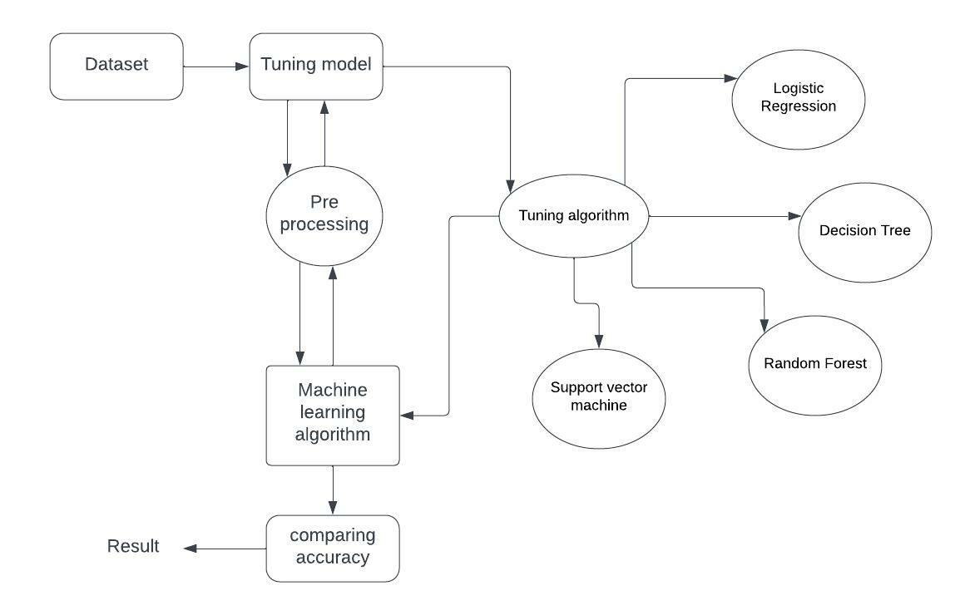
Figno.1 ER Diagram
An entity relationship diagram (ERD), also known as an entity relationship model, is a graphical representation of an information system that depicts the relationships among people, objects, places, concepts or events within that system. An ERD is a data modeling technique that can help define business processes and be used as the foundation for a relational database. Entity relationship diagrams provide a visual starting point for database design that can also be used to help determine information system requirements throughout an organization. After a relational database is rolled out, an ERD can still serve as a referral point, should any debugging or business process re-engineering be needed later.
4.2 DATA FLOW DIAGRAM
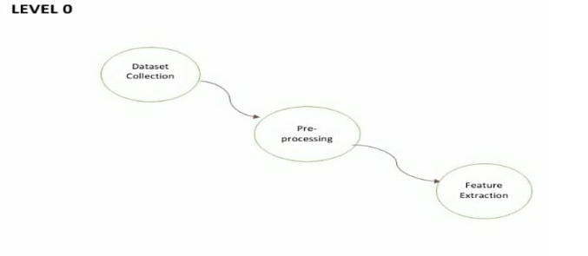

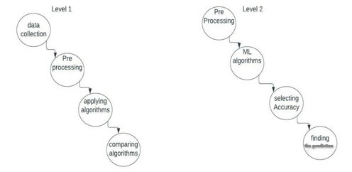

Figno.2 Data Flow Diagram
Machine learning needs data gathering have lot of past data’s. Data gathering have sufficient historical data and raw data. Before data pre-processing, raw data can’t be used directly. It’s used to preprocess then, what kind of algorithm with model. Training and testing this model working and predicting correctly with minimum errors. Tuned model involved by tuned time to time with improving the accuracy.

4.3 UML DIAGRAMS
1. USE CASE DIAGRAM
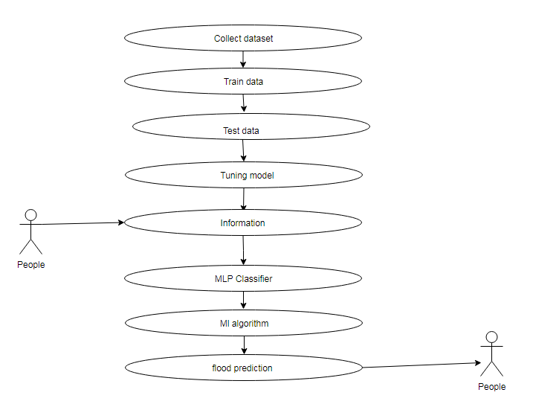

Figno.3 Use Case Diagram

Use case diagrams are considered for high level requirement analysis of a system. So when the requirements of a system are analyzed the functionalities are captured in use cases. So, it can say that uses cases are nothing but the system functionalities written in an organized manner. Now the second things which are relevant to the use cases are the actors (people).

2. CLASS DIAGRAM

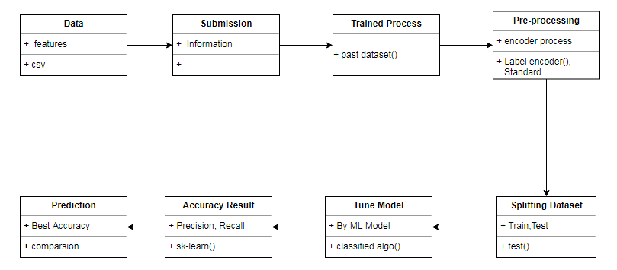
Figno.4 Class Diagram
Class diagram is basically a graphical representation of the static view of the system and represents different aspects of the application. So a collection of class diagrams represent the whole system. The name of the class diagram should be meaningful to describe the aspect of the system. Each element and their relationships should be identified in advance Responsibility (attributes and methods) of each class should be clearly identified for each class minimum number of properties should be specified and because, unnecessary properties will make the diagram complicated. Use notes whenever required to describe some aspect of the diagram and at the end of the drawing it should be understandable to the developer/coder. Finally, before
making the final version, the diagram should be drawn on plain paper and rework as many times as possible to make it correct.
3. SEQUENCE DIAGRAM

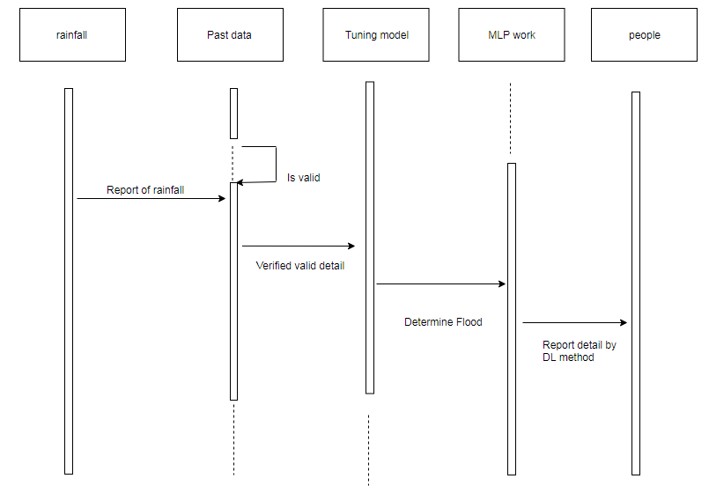
Figno.5 Sequence Diagram
Sequence diagrams model the flow of logic within your system in a visual manner, enabling you both to document and validate your logic, and are commonly used for both analysis and design purposes. Sequence diagrams are the most popular UML artifact for dynamic modeling, which focuses on identifying the behavior within your system. Other dynamic modeling techniques include activity diagramming, communication diagramming, timing diagramming and interaction overview diagramming.

4. COLLABORATION DIAGRAM

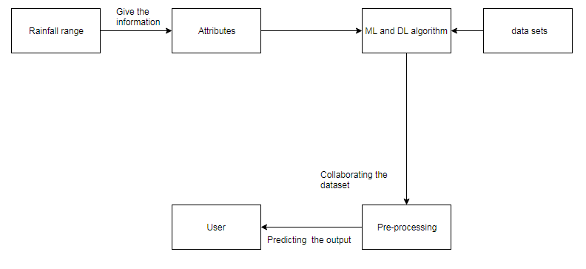
Figno.6 Collaboration Diagram

A collaboration diagram is a type of visual presentation that shows how various software objects interact with each other within an overall IT architecture and how users (like doctor or patient) can benefit from this collaboration. A collaboration diagram often comes in the form of a visual chart that resembles a flow chart. It can show, at a glance, how a single piece of software complements other parts of a greater system.

5. ACTIVITY DIAGRAM

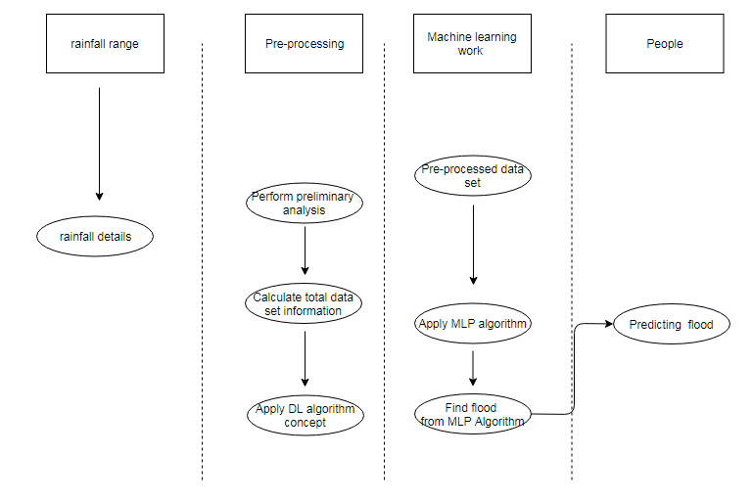

Fig No.7 Activity diagram
Activity is a particular operation of the system. Activity diagrams are not only used for visualizing dynamic nature of a system but they are also used to construct the executable system by using forward and reverse engineering techniques. The only missing thing in activity diagram is the message part. It does not show any message flow from one activity to another. Activity diagram is some time considered as the flow chart. Although the diagrams looks like a flow chart but it is not. It shows different flow like parallel, branched, concurrent and single.

4.4 WORK FLOW DIAGRAM

Source Data

Data Processing and Cleaning

Testing Dataset
Training Dataset

Best Model by Accuracy
Classification ML Algorithms

Flood Prediction

Figno.8 Workflow Diagram

The above work flow diagram represents the flow from one activity to another.Here, the first activity is collecting the dataset and next pre processing of data is done followed by training and testing of data .Then the algorithms are applied and the best accuracy is selected and the attack is predicted.

CHAPTER 5

5. SYSTEM ARCHITECTURE

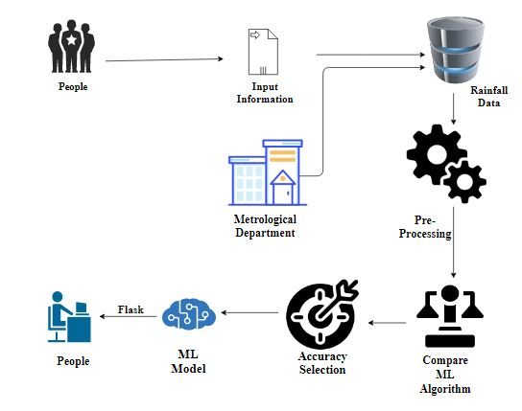
Figno.9 System Architecture

5.1 Module Design Specification

List Of Modules:
- Data Pre-processing
- Data Analysis of Visualization
- Comparing Algorithm with predction in the form of best accuracy result

Module-01
Data Pre-processing
Validation techniques in machine learning are used to get the error rate of the Machine Learning (ML) model, which can be considered as close to the true error rate of the dataset. If the data volume is large enough to be representative of the population, you may not need the validation techniques. However, in real-world scenarios, to work with samples of data that may not be a true representative of the population of given dataset. To finding the missing value, duplicate value and description of data type whether it is float variable or integer. The sample of data used to provide an unbiased evaluation of a model fit on the training dataset while tuning model hyper parameters.
The evaluation becomes more biased as skill on the validation dataset is incorporated into the model configuration. The validation set is used to evaluate a given model, but this is for frequent evaluation. It as machine learning engineers use this data to fine-tune the model hyper parameters. Data collection, data analysis, and the process of addressing data content, quality, and structure can add up to a time-consuming to-do list. During the process of data identification, it helps to understand your data and its properties; this knowledge will help you choose which algorithm to use to build your model.
A number of different data cleaning tasks using Python’s Pandas library and specifically, it focus on probably the biggest data cleaning task, missing values and it able to more quickly clean data. It wants to spend less time cleaning data, and more time exploring and modeling.
Some of the sources are just simple random mistakes. Other times, there can be a deeper reason why data is missing. It’s important to understand these different types of missing data from a statistics point of view. The type of missing data will influence how to deal with filling in the missing values and to detect missing values, and do some basic imputation and detailed statistical approach for dealing with missing data. Before, joint into code, it’s important to understand the sources of missing data. Here are some typical reasons why data is missing:
- User forgot to fill in a field.
- Data was lost while transferring manually from a legacy database.
- There was a programming error.
- Users chose not to fill out a field tied to their beliefs about how the results would be used or interpreted.

Variable identification with Uni-variate, Bi-variate and Multi-variate analysis:
- import libraries for access and functional purpose and read the given dataset
- General Properties of Analyzing the given dataset
- Display the given dataset in the form of data frame
- show columns
- shape of the data frame
- To describe the data frame
- Checking data type and information about dataset
- Checking for duplicate data
- Checking Missing values of data frame
- Checking unique values of data frame
- Checking count values of data frame
- Rename and drop the given data frame
- To specify the type of values
- To create extra columns
Data Validation/ Cleaning/Preparing Process
Importing the library packages with loading given dataset. To analyzing the variable identification by data shape, data type and evaluating the missing values, duplicate values. A validation dataset is a sample of data held back from training your model that is used to give an estimate of model skill while tuning model's and procedures that you can use to make the best use of validation and test datasets when evaluating your models. Data cleaning / preparing by rename the given dataset and drop the column etc. to analyze the uni-variate, bi-variate and multi-variate process. The steps and techniques for data cleaning will vary from dataset to dataset. The primary goal of data cleaning is to detect and remove errors and anomalies to increase the value of data in analytics and decision making.

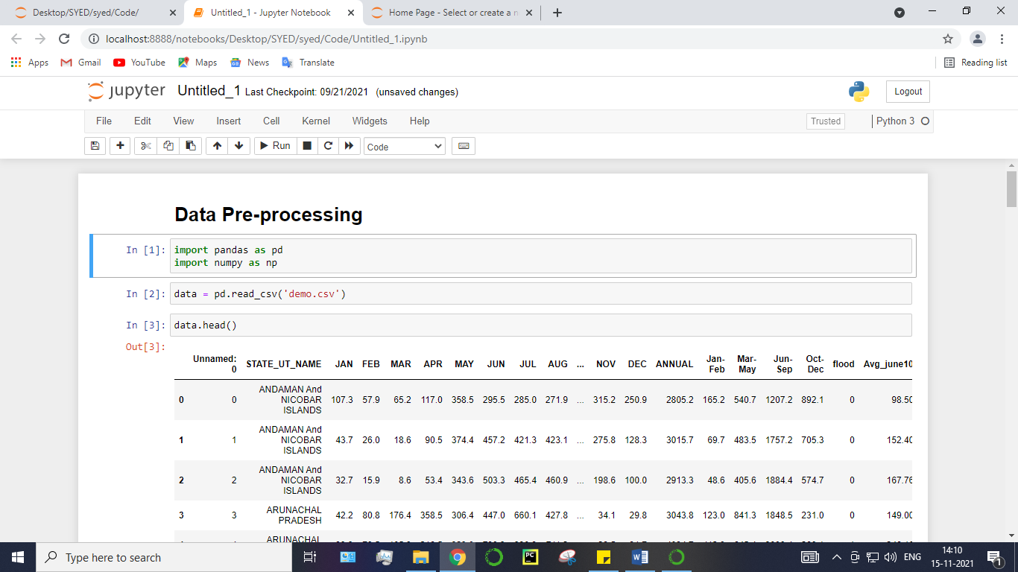
Fig no 10 : module -1

Module Diagram:
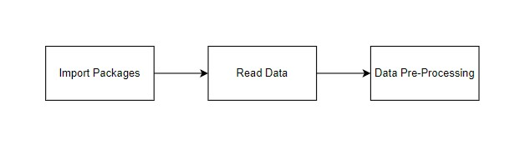

GIVEN INPUT EXPECTED OUTPUT
input : data
output : removing noisy data

Module-02
Exploration data analysis of visualization
Data visualization is an important skill in applied statistics and machine learning. Statistics does indeed focus on quantitative descriptions and estimations of data. Data visualization provides an important suite of tools for gaining a qualitative understanding. This can be helpful when exploring and getting to know a dataset and can help with identifying patterns, corrupt data, outliers, and much more. With a little domain knowledge, data visualizations can be used to express and demonstrate key relationships in plots and charts that are more visceral and stakeholders than measures of association or significance. Data visualization and exploratory data analysis are whole fields themselves and it will recommend a deeper dive into some the books mentioned at the end.
Sometimes data does not make sense until it can look at in a visual form, such as with charts and plots. Being able to quickly visualize of data samples and others is an important skill both in applied statistics and in applied machine learning. It will discover the many types of plots that you will need to know when visualizing data in Python and how to use them to better understand your own data.
- How to chart time series data with line plots and categorical quantities with bar charts.
- How to summarize data distributions with histograms and box plots.

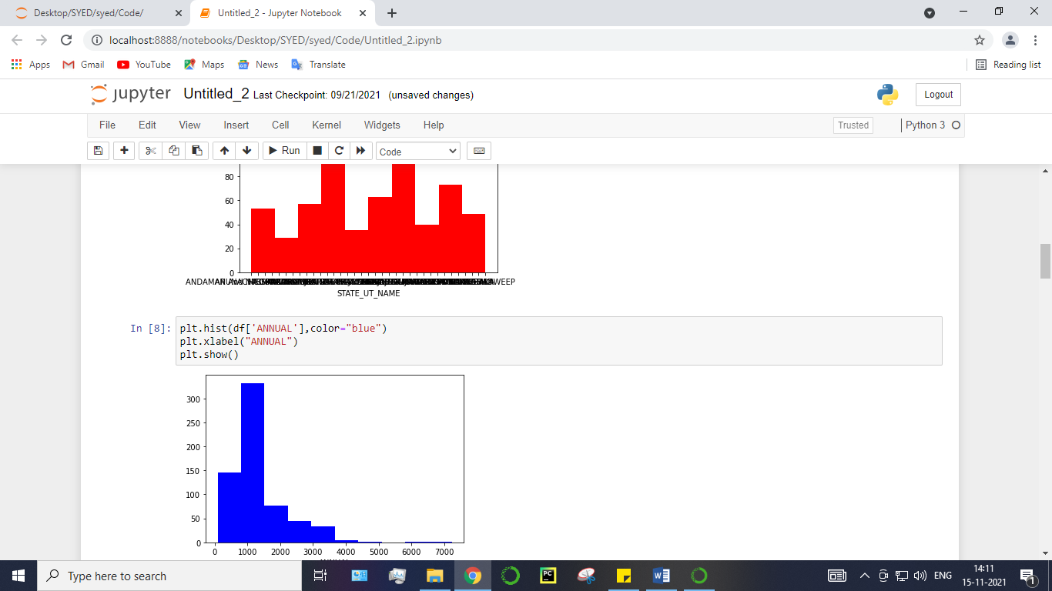

Fig no :11 module -2

Module Diagram:
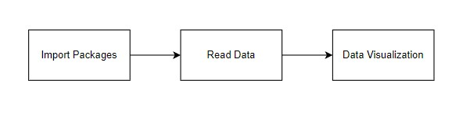
GIVEN INPUT EXPECTED OUTPUT
input : data
output : visualized data
Pre-processing refers to the transformations applied to our data before feeding it to the algorithm. Data Preprocessing is a technique that is used to convert the raw data into a clean data set. In other words, whenever the data is gathered from different sources it is collected in raw format which is not feasible for the analysis. To achieving better results from the applied model in Machine Learning method of the data has to be in a proper manner. Some specified Machine Learning model needs information in a specified format, for example, Random Forest algorithm does not support null values. Therefore, to execute random forest algorithm null values have to be managed from the original raw data set. And another aspect is that data set should be formatted in such a way that more than one Machine Learning and Deep Learning algorithms are executed in given dataset.

False Positive (FP): A person who will pay predicted as defaulter. When actual class is no and predicted class is yes. E.g. if actual class says this passenger did not survive but predicted class tells you that this passenger will survive.

False Negatives (FN): A person who default predicted as payer. When actual class is yes but predicted class in no. E.g. if actual class value indicates that this passenger survived and predicted class tells you that passenger will die.

True Positives (TP): A person who will not pay predicted as defaulter. These are the correctly predicted positive values which means that the value of actual class is yes and the value of predicted class is also yes. E.g. if actual class value indicates that this passenger survived and predicted class tells you the same thing.

True Negatives (TN): A person who default predicted as payer. These are the correctly predicted negative values which means that the value of actual class is no and value of predicted class is also no. E.g. if actual class says this passenger did not survive and predicted class tells you the same thing.

Module-03
Comparing Algorithm with prediction in the form of best accuracy result
It is important to compare the performance of multiple different machine learning algorithms consistently and it will discover to create a test harness to compare multiple different machine learning algorithms in Python with scikit-learn. It can use this test harness as a template on your own machine learning problems and add more and different algorithms to compare. Each model will have different performance characteristics. Using resampling methods like cross validation, you can get an estimate for how accurate each model may be on unseen data. It needs to be able to use these estimates to choose one or two best models from the suite of models that you have created. When have a new dataset, it is a good idea to visualize the data using different techniques in order to look at the data from different perspectives. The same idea applies to model selection. You should use a number of different ways of looking at the estimated accuracy of your machine learning algorithms in order to choose the one or two to finalize. A way to do this is to use different visualization methods to show the average accuracy, variance and other properties of the distribution of model accuracies.
In the next section you will discover exactly how you can do that in Python with scikit-learn. The key to a fair comparison of machine learning algorithms is ensuring that each algorithm is evaluated in the same way on the same data and it can achieve this by forcing each algorithm to be evaluated on a consistent test harness.
In the example below 4 different algorithms are compared:
- Logistic Regression
- Decision Tree Classifier
- Random Forest Classifier
- Support Vector Machine

The K-fold cross validation procedure is used to evaluate each algorithm, importantly configured with the same random seed to ensure that the same splits to the training data are performed and that each algorithm is evaluated in precisely the same way. Before that comparing algorithm, Building a Machine Learning Model using install Scikit-Learn libraries. In this library package have to done preprocessing, linear model with logistic regression method, cross validating by KFold method, ensemble with random forest method and tree with decision tree classifier. Additionally, splitting the train set and test set. To predicting the result by comparing accuracy.

Prediction result by accuracy:
Logistic regression algorithm also uses a linear equation with independent predictors to predict a value. The predicted value can be anywhere between negative infinity to positive infinity. It need the output of the algorithm to be classified variable data. Higher accuracy predicting result is logistic regression model by comparing the best accuracy.

True Positive Rate(TPR) = TP / (TP + FN)
False Positive rate(FPR) = FP / (FP + TN)

Accuracy: The Proportion of the total number of predictions that is correct otherwise overall how often the model predicts correctly defaulters and non-defaulters.

Accuracy calculation:
Accuracy = (TP + TN) / (TP + TN + FP + FN)
Accuracy is the most intuitive performance measure and it is simply a ratio of correctly predicted observation to the total observations. One may think that, if we have high accuracy then our model is best. Yes, accuracy is a great measure but only when you have symmetric datasets where values of false positive and false negatives are almost same.
Precision: The proportion of positive predictions that are actually correct.
Precision = TP / (TP + FP)
Precision is the ratio of correctly predicted positive observations to the total predicted positive observations. The question that this metric answer is of all passengers that labeled as survived, how many actually survived? High precision relates to the low false positive rate. We have got 0.788 precision which is pretty good.

Recall: The proportion of positive observed values correctly predicted. (The proportion of actual defaulters that the model will correctly predict)
Recall = TP / (TP + FN)
Recall(Sensitivity) - Recall is the ratio of correctly predicted positive observations to the all observations in actual class - yes.

F1 Score is the weighted average of Precision and Recall. Therefore, this score takes both false positives and false negatives into account. Intuitively it is not as easy to understand as accuracy, but F1 is usually more useful than accuracy, especially if you have an uneven class distribution. Accuracy works best if false positives and false negatives have similar cost. If the cost of false positives and false negatives are very different, it’s better to look at both Precision and Recall.

General Formula:
F- Measure = 2TP / (2TP + FP + FN)

F1-Score Formula:
F1 Score = 2*(Recall * Precision) / (Recall + Precision)
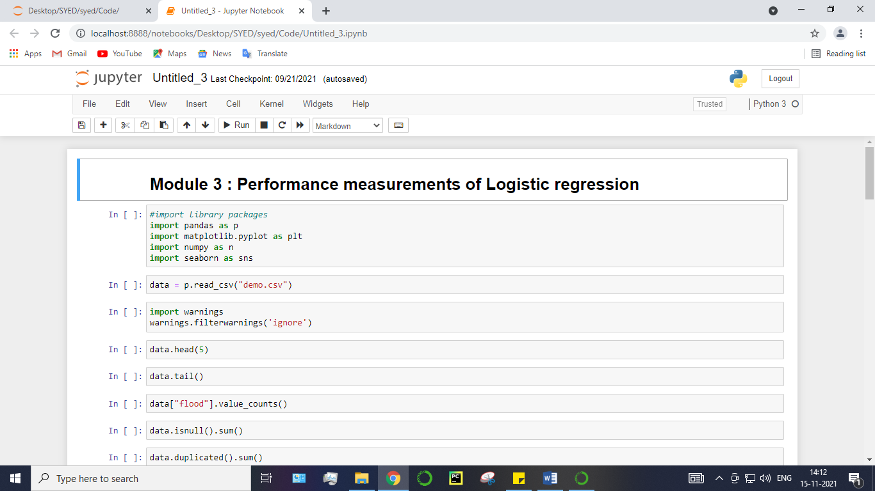
Fig no :12 module- 3

5.2 Algorithms
In machine learning and statistics, classification is a supervised learning approach in which the computer program learns from the data input given to it and then uses this learning to classify new observation.
This data set may simply be bi-class (like identifying whether the person is male or female or that the mail is spam or non-spam) or it may be multi-class too. Some examples of classification problems are: speech recognition, handwriting recognition, bio metric identification, document classification etc.
In Supervised Learning, algorithms learn from labeled data. After understanding the data, the algorithm determines which label should be given to new data based on pattern and associating the patterns to the unlabeled new data.

1.Logistic Regression:
It is a statistical method for analysing a data set in which there are one or more independent variables that determine an outcome. The outcome is measured with a dichotomous variable (in which there are only two possible outcomes). The goal of logistic regression is to find the best fitting model to describe the relationship between the dichotomous characteristic of interest (dependent variable = response or outcome variable) and a set of independent (predictor or explanatory) variables. Logistic regression is a Machine Learning classification algorithm that is used to predict the probability of a categorical dependent variable. In logistic regression, the dependent variable is a binary variable that contains data coded as 1 (yes, success, etc.) or 0 (no, failure, etc.).
In other words, the logistic regression model predicts P(Y=1) as a function of X. Logistic regression Assumptions:
- Binary logistic regression requires the dependent variable to be binary.
- For a binary regression, the factor level 1 of the dependent variable should represent the desired outcome.
- Only the meaningful variables should be included.
- The independent variables should be independent of each other. That is, the model should have little.
- The independent variables are linearly related to the log odds.
- Logistic regression requires quite large sample sizes.

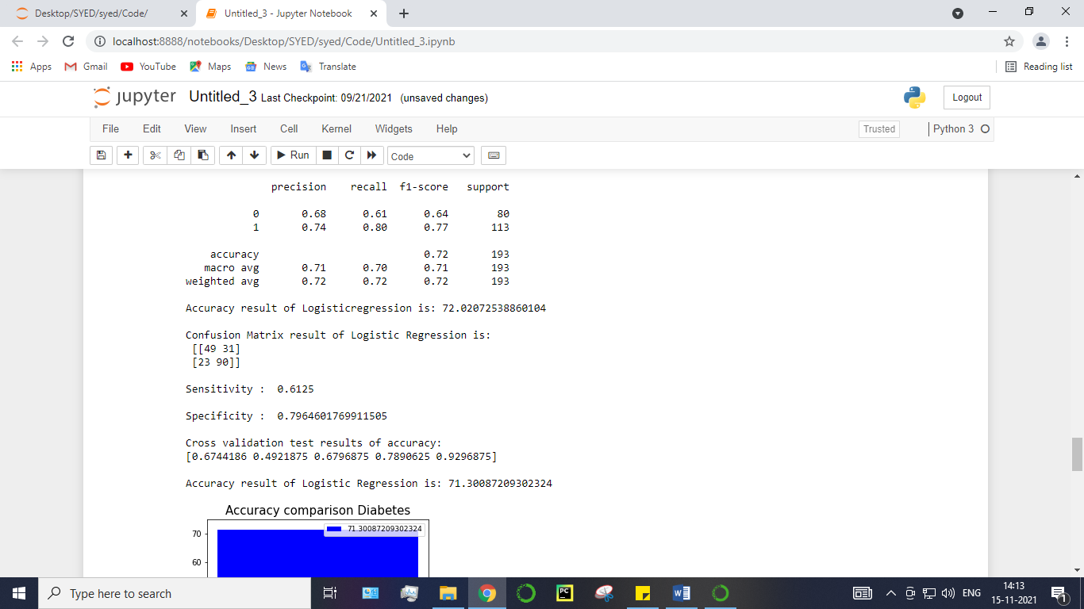
Fig no :13 accuracy result of algorithm -1

2.Decision Tree:
It is one of the most powerful and popular algorithm. Decision-tree algorithm falls under the category of supervised learning algorithms. It works for both continuous as well as categorical output variables. Assumptions of Decision tree:
- At the beginning, we consider the whole training set as the root.
- Attributes are assumed to be categorical for information gain, attributes are assumed to be continuous.
- On the basis of attribute values records are distributed recursively.
- We use statistical methods for ordering attributes as root or internal node.
Decision tree builds classification or regression models in the form of a tree structure. It breaks down a data set into smaller and smaller subsets while at the same time an associated decision tree is incrementally developed. A decision node has two or more branches and a leaf node represents a classification or decision. The topmost decision node in a tree which corresponds to the best predictor called root node. Decision trees can handle both categorical and numerical data. Decision tree builds classification or regression models in the form of a tree structure. It utilizes an if-then rule set which is mutually exclusive and exhaustive for classification. The rules are learned sequentially using the training data one at a time. Each time a rule is learned, the tuples covered by the rules are removed.
This process is continued on the training set until meeting a termination condition. It is constructed in a top-down recursive divide-and-conquer manner. All the attributes should be categorical. Otherwise, they should be discretized in advance. Attributes in the top of the tree have more impact towards in the classification and they are identified using the information gain concept. A decision tree can be easily over-fitted generating too many branches and may reflect anomalies due to noise or outliers.

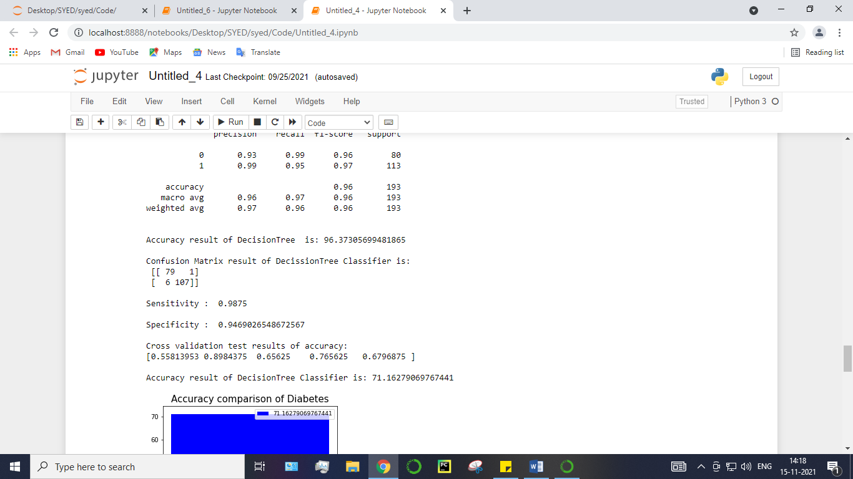
Fig no :14 accuracy result of algorithm -2

3.Random Forest Classifier:
Random forests or random decision forests are an ensemble learning method for classification, regression and other tasks, that operate by constructing a multitude of decision trees at training time and outputting the class that is the mode of the classes (classification) or mean prediction (regression) of the individual trees. Random decision forests correct for decision trees’ habit of over fitting to their training set. Random forest is a type of supervised machine learning algorithm based on ensemble learning. Ensemble learning is a type of learning where you join different types of algorithms or same algorithm multiple times to form a more powerful prediction model. The random forest algorithm combines multiple algorithm of the same type i.e. multiple decision trees, resulting in a forest of trees, hence the name "Random Forest". The random forest algorithm can be used for both regression and classification tasks.
The following are the basic steps involved in performing the random forest algorithm:
- Pick N random records from the dataset.
- Build a decis Choose the number of trees you want in your algorithm and repeat steps 2.
- Desicion tree based on these N records.
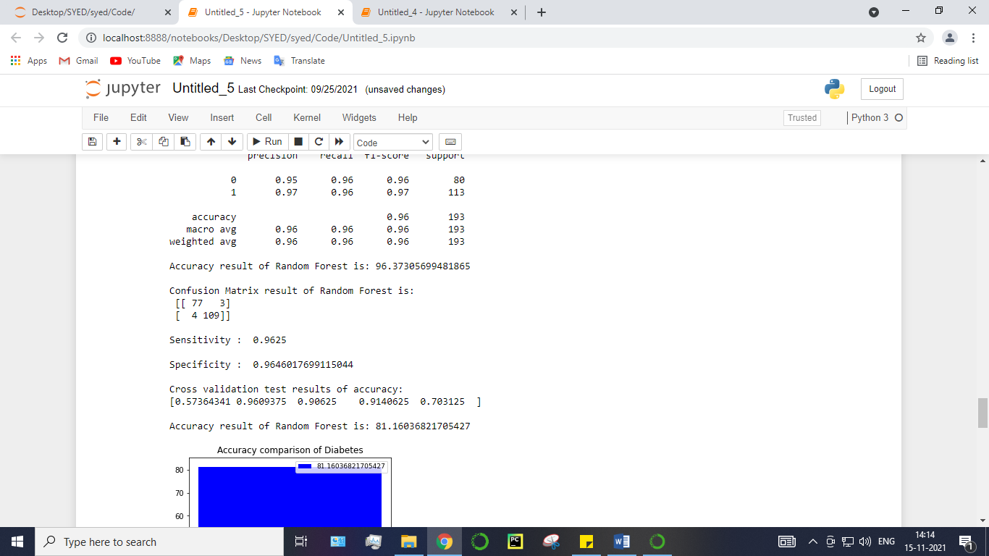
Fig no :15 accuracy result of algorithm -3
4.Support Vector Machines
A classifier that categorizes the data set by setting an optimal hyper plane between data. I chose this classifier as it is incredibly versatile in the number of different kernelling functions that can be applied and this model can yield a high predictability rate. Support Vector Machines are perhaps one of the most popular and talked about machine learning algorithms. They were extremely popular around the time they were developed in the 1990s and continue to be the go-to method for a high-performing algorithm with little tuning.
- How to disentangle the many names used to refer to support vector machines.
- The representation used by SVM when the model is actually stored on disk.
- How a learned SVM model representation can be used to make predictions for new data.
- How to learn an SVM model from training data.
- How to best prepare your data for the SVM algorithm.
- Where you might look to get more information on SVM.

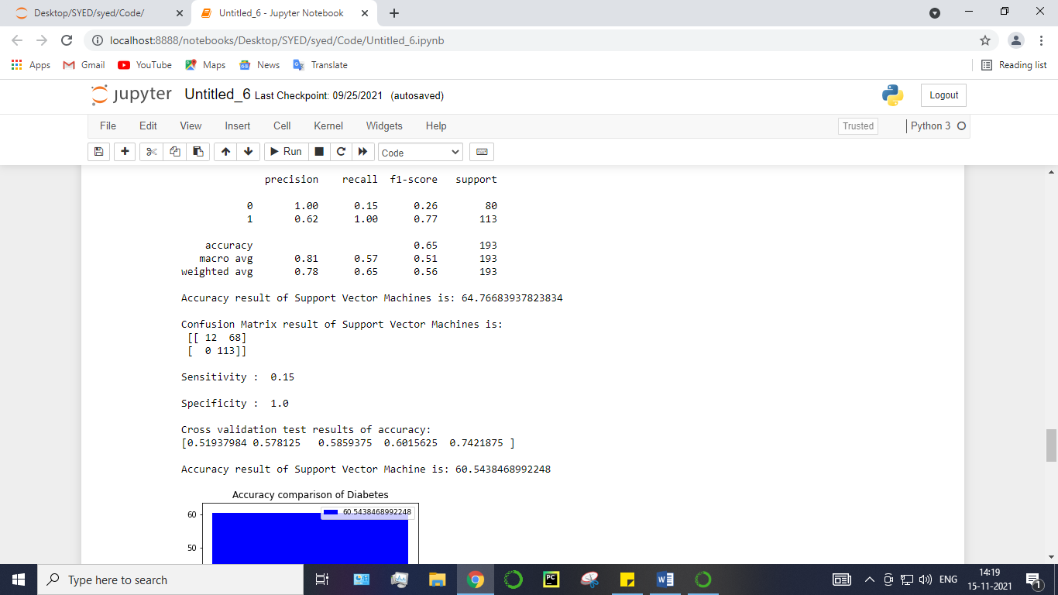
Fig no:16 accuracy result of algorithm-4

CHAPTER 6

6. SYSTEM IMPLEMENTATION

6.1 Module – 1
import pandas as pd
import numpy as np

data = pd.read_csv('demo.csv')
data.head()
data.shape
df = data.dropna()
df.head()
df.shape
df.columns
df.info()
df.describe()
df.isnull()
df.isnull().sum()
df.STATE_UT_NAME.unique()
df.columns
df.flood.unique()
df.JAN.unique().mean()
df.FEB.unique().mean()
df.ANNUAL.unique().min()
df.ANNUAL.unique().max()
df.ANNUAL.unique().mean()
df.Avg_june10days.unique()
df.corr()

6.2 Module – 2
import pandas as pd
import numpy as np
import matplotlib.pyplot as plt
import seaborn as sns

df = pd.read_csv('demo.csv')
import warnings
warnings.filterwarnings('ignore')

df.head()
df.shape
df.columns
plt.hist(df['STATE_UT_NAME'],color="red")
plt.xlabel("STATE_UT_NAME")
plt.show()
plt.hist(df['ANNUAL'],color="blue")
plt.xlabel("ANNUAL")
plt.show()
plt.figure(figsize=(10,6))
plt.plot(df['ANNUAL'])
plt.show()
fig, ax = plt.subplots(figsize=(18,13))
sns.heatmap(df.corr(), ax=ax, annot=True)
boxplot = df.boxplot(column=['ANNUAL'], by="flood",figsize=(8,6), fontsize=15)
plt.show()

def PropByVar(df, variable):
dataframe_pie = df[variable].value_counts()
ax = dataframe_pie.plot.pie(figsize=(8,12), autopct='%1.2f%%', fontsize = 12)
ax.set_title(variable + ' \n', fontsize = 15)
plt.show()
return np.round(dataframe_pie/df.shape[0]*100,2)
PropByVar(df,"flood")
plt.show()

plt.figure(figsize=(12,8))
plt.scatter(df["ANNUAL"],df["flood"],color="black")
data1=df.iloc[:,:9]
data2=df.iloc[:,9:-1]
a=pd.plotting.scatter_matrix(data1, alpha=0.05, figsize=(18,10), diagonal='hist')
axis = 'off'

plt.show()

6.3 Module - 3 : Performance measurements of Logistic regression
#import library packages
import pandas as p
import matplotlib.pyplot as plt
import numpy as n
import seaborn as sns

data = p.read_csv("demo.csv")
import warnings
warnings.filterwarnings('ignore')

data.head(5)
data.tail()
data["flood"].value_counts()
data.isnull().sum()
data.duplicated().sum()
data.columns
data.shape

del data['JAN']
del data['Unnamed: 0']
del data['FEB']
del data['MAR']
del data['APR']
del data['MAY']
del data['JUN']
del data['JUL']
del data['AUG']
del data['SEP']
del data['OCT']
del data['NOV']
del data['DEC']
del data['Avg_june10days']
del data['maytojune']
data.head()

from sklearn.preprocessing import LabelEncoder

var_mod=["STATE_UT_NAME"]
le = LabelEncoder()
for i in var_mod:
data[i] = le.fit_transform(data[i]).astype(int)
data.head()
predictLR = logR.predict(X_test)

print("")
print('Classification report of Logistic Regression Results:')
print("")
print(classification_report(y_test,predictLR))
x = (accuracy_score(y_test,predictLR)*100)

print('Accuracy result of Logisticregression is:', x)

print("")

cm2=confusion_matrix(y_test,predictLR)
print('Confusion Matrix result of Logistic Regression is:\n',cm2)
print("")
PPV = TP/(TP+FP)
NPV = TN/(TN+FN)
print("Positive Predictive Value :",PPV)
print("Negative predictive value :",NPV)

cm2=confusion_matrix(y_test, predictLR)
print(cm2)
sns.heatmap(cm2/n.sum(cm2), annot=True, cmap = 'Blues', annot_kws={"size": 16}, fmt='.2%',)
plt.show()

6.4 Module 4 : Performance measurements of Decision Tree:
#import library packages
import pandas as p
import matplotlib.pyplot as plt
import numpy as n
import seaborn as sns

data = p.read_csv("demo.csv")
import warnings
warnings.filterwarnings('ignore')
data.head(5)
data.tail()
data["flood"].value_counts()
data.isnull().sum()
data.duplicated().sum()
data.columns
data.shape

del data['JAN']
del data['Unnamed: 0']
del data['FEB']
del data['MAR']
del data['APR']
del data['MAY']
del data['JUN']
del data['JUL']
del data['AUG']
del data['SEP']
del data['OCT']
del data['NOV']
del data['DEC']
del data['Avg_june10days']
del data['maytojune']
data.head()

from sklearn.preprocessing import LabelEncoder

var_mod=["STATE_UT_NAME"]
le = LabelEncoder()
for i in var_mod:
data[i] = le.fit_transform(data[i]).astype(int)
data.head()

DT=DecisionTreeClassifier()

DT.fit(X_train,y_train)

predictDT = DT.predict(X_test)

print("")
print('Classification report DecisionTree classifier Results:')
print("")
print(classification_report(y_test,predictDT))

print("")
x = (accuracy_score(y_test,predictDT)*100)

print('Accuracy result of DecisionTree is:', x)
print("")

cm2=confusion_matrix(y_test,predictDT)
print('Confusion Matrix result of DecissionTree Classifier is:\n',cm2)
print("")
sensitivity2 = cm2[0,0]/(cm2[0,0]+cm2[0,1])
print('Sensitivity : ', sensitivity2 )
print("")
specificity2 = cm2[1,1]/(cm2[1,0]+cm2[1,1])
print('Specificity : ', specificity2)
print("")

accuracy = cross_val_score(DT, X, y, scoring='accuracy')
print('Cross validation test results of accuracy:')
print(accuracy)
#get the mean of each fold
print("")
print("Accuracy result of DecisionTree Classifier is:",accuracy.mean() * 100)
dt=accuracy.mean() * 100

def graph():
import matplotlib.pyplot as plt
data=[dt]
alg="Decision Tree"
plt.figure(figsize=(5,5))
b=plt.bar(alg,data,color=("b"))
plt.title("Accuracy comparison of Diabetes",fontsize=15)
plt.legend(b,data,fontsize=9)

graph()
TN = cm2[1][0]
FN = cm2[0][0]
TP = cm2[1][1]
FP = cm2[0][1]
print("True Positive :",TP)
print("True Negative :",TN)
print("False Positive :",FP)
print("False Negative :",FN)
print("")
TPR = TP/(TP+FN)
TNR = TN/(TN+FP)
FPR = FP/(FP+TN)
FNR = FN/(TP+FN)
print("True Positive Rate :",TPR)
print("True Negative Rate :",TNR)
print("False Positive Rate :",FPR)
print("False Negative Rate :",FNR)
print("")
PPV = TP/(TP+FP)
NPV = TN/(TN+FN)
print("Positive Predictive Value :",PPV)
print("Negative predictive value :",NPV)

cm2=confusion_matrix(y_test, predictDT)
print(cm2)
sns.heatmap(cm2/n.sum(cm2), annot=True, cmap = 'Blues', annot_kws={"size": 16}, fmt='.2%',)
plt.show()

6.5 Module – 5
#import library packages
import pandas as p
import matplotlib.pyplot as plt
import numpy as n
import seaborn as sns

data = p.read_csv("demo.csv")
import warnings
warnings.filterwarnings('ignore')
data.head(5)
data.tail()
data["flood"].value_counts()
data.isnull().sum()
data.duplicated().sum()
data.columns
data.shape

del data['JAN']
del data['Unnamed: 0']
del data['FEB']
del data['MAR']
del data['APR']
del data['MAY']
del data['JUN']
del data['JUL']
del data['AUG']
del data['SEP']
del data['OCT']
del data['NOV']
del data['DEC']
del data['Avg_june10days']
del data['maytojune']

data.head()
from sklearn.preprocessing import LabelEncoder

var_mod=["STATE_UT_NAME"]
le = LabelEncoder()
for i in var_mod:
data[i] = le.fit_transform(data[i]).astype(int)
data.head()
rfc = RandomForestClassifier()
rfc.fit(X_train,y_train)
predictR = rfc.predict(X_test)
print("")
print('Classification report of Random Forest Results:')
print("")
print(classification_report(y_test,predictR))
x = (accuracy_score(y_test,predictR)*100)
print('Accuracy result of Random Forest is:', x)
print("")
cm1=confusion_matrix(y_test,predictR)
print('Confusion Matrix result of Random Forest is:\n',cm1)
print("")
sensitivity1 = cm1[0,0]/(cm1[0,0]+cm1[0,1])
print('Sensitivity : ', sensitivity1 )
print("")
specificity1 = cm1[1,1]/(cm1[1,0]+cm1[1,1])
print('Specificity : ', specificity1)
print("")

accuracy = cross_val_score(rfc, X, y, scoring='accuracy')
print('Cross validation test results of accuracy:')
print(accuracy)
#get the mean of each fold
print("")
print("Accuracy result of Random Forest is:",accuracy.mean() * 100)
RFC=accuracy.mean() * 100

def graph():
import matplotlib.pyplot as plt
data=[RFC]
alg="Random orest"
plt.figure(figsize=(5,5))
b=plt.bar(alg,data,color=("b"))
plt.title("Accuracy comparison of Diabetes")
plt.legend(b,data,fontsize=9)

graph()
TN = cm1[1][0]
FN = cm1[0][0]
TP = cm1[1][1]
FP = cm1[0][1]
print("True Positive :",TP)
print("True Negative :",TN)
print("False Positive :",FP)
print("False Negative :",FN)
print("")
TPR = TP/(TP+FN)
TNR = TN/(TN+FP)
FPR = FP/(FP+TN)
FNR = FN/(TP+FN)
print("True Positive Rate :",TPR)
print("True Negative Rate :",TNR)
print("False Positive Rate :",FPR)
print("False Negative Rate :",FNR)
print("")
PPV = TP/(TP+FP)
NPV = TN/(TN+FN)
print("Positive Predictive Value :",PPV)
print("Negative predictive value :",NPV)

cm2=confusion_matrix(y_test, predictR)
print(cm2)
sns.heatmap(cm2/n.sum(cm2), annot=True, cmap = 'Blues', annot_kws={"size": 16}, fmt='.2%',)
plt.show()

import joblib
joblib.dump(rfc, 'flood.pkl')

6.6 Module – 6
#import library packages
import pandas as p
import matplotlib.pyplot as plt
import numpy as n
import seaborn as sns

data = p.read_csv("demo.csv")
import warnings
warnings.filterwarnings('ignore')
data.head(5)
data.tail()
data["flood"].value_counts()
data.isnull().sum()
data.duplicated().sum()
data.columns
data.shape

del data['JAN']
del data['Unnamed: 0']
del data['FEB']
del data['MAR']
del data['APR']
del data['MAY']
del data['JUN']
del data['JUL']
del data['AUG']
del data['SEP']
del data['OCT']
del data['NOV']
del data['DEC']
del data['Avg_june10days']
del data['maytojune']

data.head()
from sklearn.preprocessing import LabelEncoder

var_mod=["STATE_UT_NAME"]
le = LabelEncoder()
for i in var_mod:
data[i] = le.fit_transform(data[i]).astype(int)
data.head()
s = SVC()
s.fit(X_train,y_train)
predicts = s.predict(X_test)
print("")
print('Classification report of Support Vector Machines Results:')
print("")
print(classification_report(y_test,predicts))
x = (accuracy_score(y_test,predicts)*100)
print('Accuracy result of Support Vector Machines is:', x)
print("")
cm2=confusion_matrix(y_test,predicts)
print('Confusion Matrix result of Support Vector Machines is:\n',cm2)
print("")
sensitivity1 = cm2[0,0]/(cm2[0,0]+cm2[0,1])
print('Sensitivity : ', sensitivity1 )
print("")
specificity1 = cm2[1,1]/(cm2[1,0]+cm2[1,1])
print('Specificity : ', specificity1)
print("")

accuracy = cross_val_score(s, X, y, scoring='accuracy')
print('Cross validation test results of accuracy:')
print(accuracy)
#get the mean of each fold
print("")
print("Accuracy result of Support Vector Machine is:",accuracy.mean() * 100)
S=accuracy.mean() * 100

def graph():
import matplotlib.pyplot as plt
data=[S]
alg="Support Vector Machine"
plt.figure(figsize=(5,5))
b=plt.bar(alg,data,color=("b"))
plt.title("Accuracy comparison of Diabetes")
plt.legend(b,data,fontsize=9)

graph()
TN = cm2[1][0]
FN = cm2[0][0]
TP = cm2[1][1]
FP = cm2[0][1]
print("True Positive :",TP)
print("True Negative :",TN)
print("False Positive :",FP)
print("False Negative :",FN)
print("")
TPR = TP/(TP+FN)
TNR = TN/(TN+FP)
FPR = FP/(FP+TN)
FNR = FN/(TP+FN)
print("True Positive Rate :",TPR)
print("True Negative Rate :",TNR)
print("False Positive Rate :",FPR)
print("False Negative Rate :",FNR)
print("")
PPV = TP/(TP+FP)
NPV = TN/(TN+FN)
print("Positive Predictive Value :",PPV)
print("Negative predictive value :",NPV)

cm2=confusion_matrix(y_test, predicts)
print(cm2)
sns.heatmap(cm2/n.sum(cm2), annot=True, cmap = 'Blues', annot_kws={"size": 16}, fmt='.2%',)
plt.show()

CHAPTER 7

7. PERFORMANCE ANALYSIS
7.1 Accuracy & Comparison of Results

MODEL | ACCURACY
Logistic Regression | 71.3
Decision Tree | 71.6
Random Forest | 81.1
Support Vector Machine | 60.5

7.2 CONFUSION MATRIX
A confusion matrix gives us a matrix as output and describes the complete performance of the model. Classification of a test dataset produces four outcomes – true positive, false positive, true negative, and false negative.
True positive (TP): correct positive prediction
False positive (FP): incorrect positive prediction
True negative (TN): correct negative prediction
False negative (FN): incorrect negative prediction

LOGISTIC REGRESSION
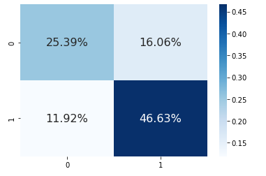

True positive (TP): 25.39%
False positive (FP): 11.92%
True negative (TN): 46.63%
False negative (FN):16.06%

DECISION TREE CLASSIFIER
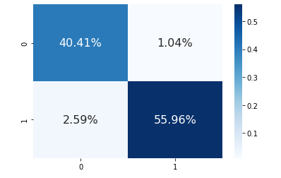
True positive (TP): 40.41%
False positive (FP): 2.59%
True negative (TN): 1.04%
False negative (FN):55.96%
RANDOM FOREST

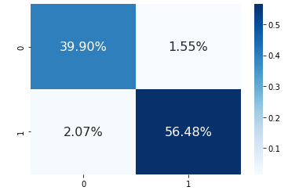

True positive (TP): 39.90%
False positive (FP): 56.48%
True negative (TN): 1.55%
False negative (FN):56.48%

SUPPORT VECTOR MACHINE

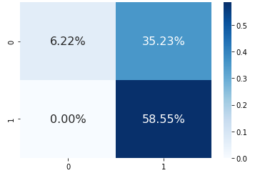

True positive (TP): 6.22%
False positive (FP): 0.00%
True negative (TN):35.23 %
False negative (FN):58.55%

CHAPTER 8

8. CONCLUSION
8.1 CONCLUSION
The analytical process started from data cleaning and processing, missing value, exploratory analysis and finally model building and evaluation. Finally we predict the flash flood using machine learning algorithm with different results. This brings some of the following insights about flood prediction.

8.2 FUTURE WORK :
- Disaster management wants to automate the detecting the flood happened or not from eligibility process (real time).
- To automate this process by show the prediction result in web application or desktop application.
- To optimize the work to implement in Artificial Intelligence environment

APPENDICES
A.1 SAMPLE SCREENS
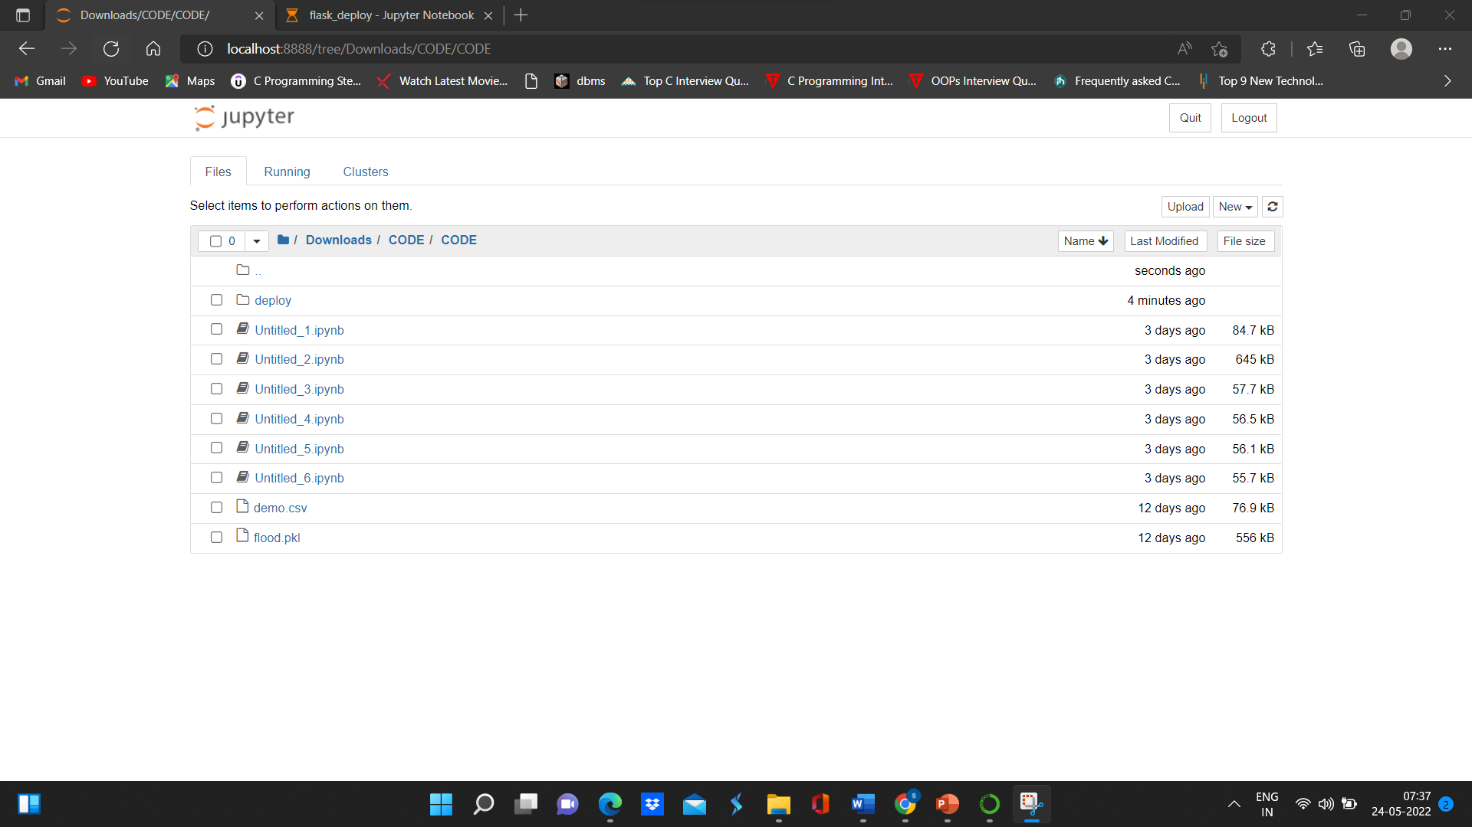
Fig No:17 Coding Folders

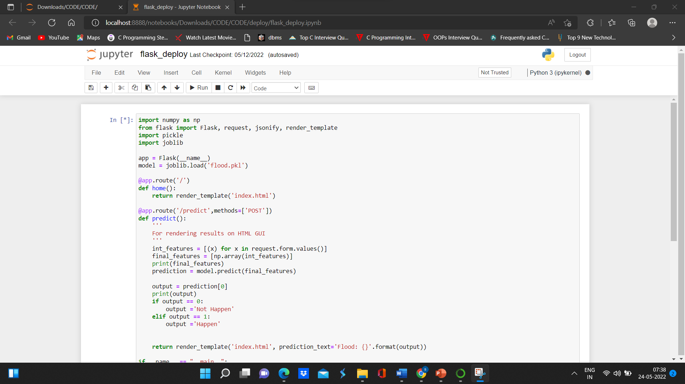
Fig No:18 Sample code



Fig No: 19 User Interface

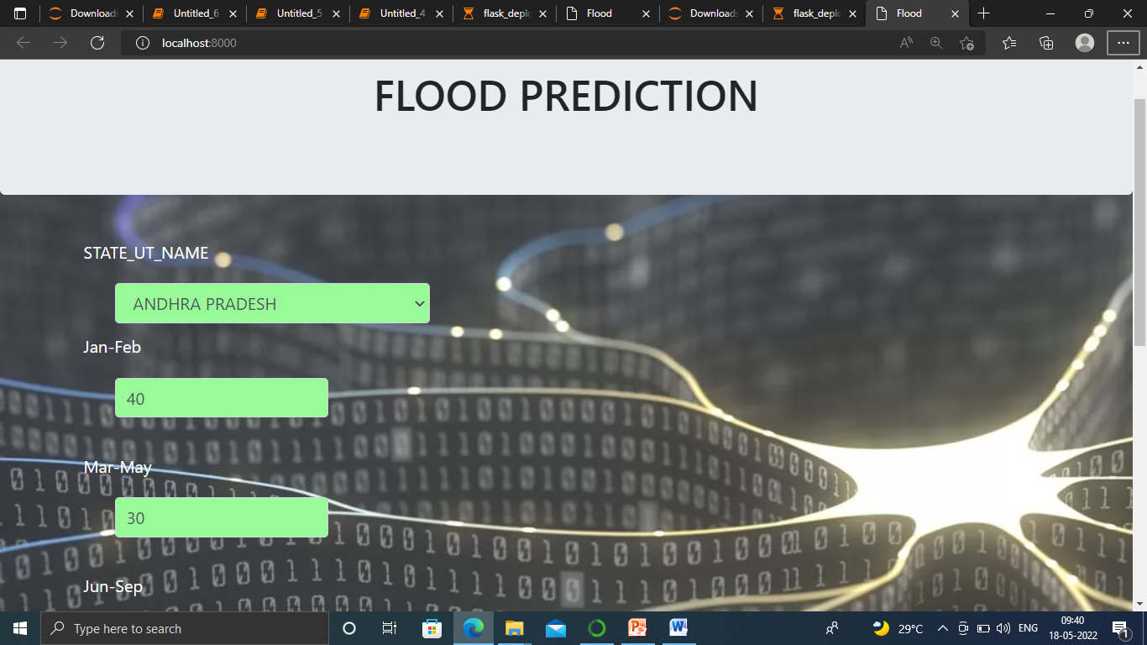

Fig No: 20 Entering Rainfall Range



Fig No:21 Predicted output

REFERENCES

[1] Akshya.J,P.L.K.Priyadarsini, A hybrid machine learning approach for classifying aerial images of flood-hit areas,2019.
[2] Swapnil bande,Virendra V. Shete ,Smart flood disaster prediction system using IOT & Neural Networks,2017.
[3] Febus Reidj G.Cruz,Mathew G.Binag,Marlou Ryan G,Francis Aldrine.A,2018.
[4] Ni Komang Ega Karthika,Muhammad Ary Murti, Casi setianingsih ,Floods prediction using radial basis function based on internet of things,2019.
[5] T Gurleen Kaur,Anju Bala,An efficient automated hybrud algorithm to predict floods in cloud environment,2019.
[6] Fazlina Ahmat Ruslan,Khadijah Haron,Ramli Adnan,Multiple input single output ARX an ARMAX model of flood prediction system ,2017.
[7] Indrastanti R. Widiasari , Lukito Edi Nugoho, Widyawan,Context based hydrology time series data for a flood prediction model,2018.
[8] Pengzhan Cui,Yeqin Guan,Ying Zhu,Flood Loss Prediction of Coastal city based on GMM-ANN,2017.
[9] Xilin Xia,Qiuhua Liang,Xiaodong,Ming,Jingming HouAn efficient and stable hydrodynamic model with novel source term for flood simulations,2017.
[10] Siriporn Supratid,thannob airbag,An integration of stationary wavelet transform and nonlinear aggressive neural network for baseline and future forecasting of reservoir inflow,2017.

